Physical Database Design

Part 1: Introduction

Project Overview
The goal of this project is to design and refine a relational database that accurately represents the data requirements identified in earlier phases. The system stores core entities, their attributes, and the relationships that connect them, allowing information to be efficiently retrieved, updated, and maintained. This phase continues the development of a structured data model that supports dependable data storage and clear interpretation for all intended use cases.

Scope
The scope of the project focuses strictly on defining and modeling the essential entities, attributes, and relationships required by the system’s data needs. This includes building a complete and logically consistent ER model, applying key constraints to preserve integrity, and ensuring that all relevant data elements are represented. Features such as user interfaces, external system integration, or advanced analytics remain outside the scope. The intent is to provide a well-structured blueprint that supports future implementation but remains concentrated on data modeling only.

Glossary
Entity – An object or concept represented in the database.
Attribute – A descriptive property of an entity.
Relationship – A logical connection between two or more entities.
Cardinality – Defines the numerical constraints of relationships.
Primary Key (PK) – A unique attribute (or set of attributes) identifying each record.
Foreign Key (FK) – An attribute that references a primary key in another table to establish a relationship.
Candidate Key – A minimal set of attributes that uniquely identifies a tuple.
Supertype – A generalized entity containing attributes shared by its related subtypes.
Subtype – A specialized entity that inherits from a supertype and may contain additional attributes.
ER Model – A diagram showing entities, attributes, and relationships.
Transaction – A logical unit of work made up of one or more operations treated as a single action.
Composite Attribute – An attribute made of multiple sub-attributes.
Multivalued Attribute – An attribute that can hold multiple values for a single entity instance.
Weak Entity – An entity that depends on another entity’s primary key for identification.
Surrogate Key – A system-generated identifier used as a primary key when no natural key is suitable.

Part 2: Choose Your Platform
For this project, I selected MySQL as the database platform because I already have experience using it in previous coursework and personal projects. This familiarity makes setup and implementation faster, allowing me to focus more on designing the schema rather than learning a new system.
MySQL fits well with the course requirements and fully supports key relational features such as primary keys, foreign keys, check constraints, and transactions. Using MySQL Workbench also makes it easy to run scripts, populate data, inspect tables, and debug issues.

Part 3: Create Your Database

To build the physical database for the Library Management System, I executed my DDL script (create_tables.sql) in MySQL Workbench.
This script defines all tables in the schema, including MembershipType, Client, Item, Book, Magazine, DigitalMedia, AuthorCreator, ItemAuthor, Loan, Reservation, Payment, and Notification.
The script successfully created all tables with their required primary keys, foreign keys, check constraints, ENUM types, and cascading rules.
create_tables
After creating the schema, I verified table dependencies using the MySQL Schema Inspector and confirmed that all supertype–subtype and many-to-many relationships were implemented correctly.
All SQL scripts in the project are organized as separate files:
- create_tables.sql — physical schema (DDL)
- populate_data.sql — sample data population (DML)
populate_data
- test_queries.sql — required functional queries and reporting queries
test_queries
Each script includes comments explaining its purpose, structure, and execution order.
Running the DDL script produced a consistent, complete, and fully functional physical database schema.

Part 4: Print Your Physical Scheme
-- =====================================================================
-- 1. MembershipType
-- =====================================================================
CREATE TABLE MembershipType (
MembershipTypeID INT PRIMARY KEY,
Name VARCHAR(50) NOT NULL,
MaxConcurrentLoans INT NOT NULL CHECK (MaxConcurrentLoans >= 0),
LoanDurationDays INT NOT NULL CHECK (LoanDurationDays >= 1),
DailyLateFee DECIMAL(6,2) NOT NULL CHECK (DailyLateFee >= 0),
ReservationLimit INT NOT NULL CHECK (ReservationLimit >= 0)
);

-- =====================================================================
-- 2. Client
-- =====================================================================
CREATE TABLE Client (
ClientID INT PRIMARY KEY,
FullName VARCHAR(120) NOT NULL,
Email VARCHAR(120) UNIQUE NOT NULL,
Phone VARCHAR(25),
Address VARCHAR(255),
JoinDate DATE,
AccountStatus ENUM('Active','Suspended','Closed') NOT NULL DEFAULT 'Active',
MembershipTypeID INT NOT NULL,

CONSTRAINT fk_client_membership
FOREIGN KEY (MembershipTypeID) REFERENCES MembershipType(MembershipTypeID)
);

-- =====================================================================
-- 3. Item (supertype)
-- =====================================================================
CREATE TABLE Item (
ItemID INT PRIMARY KEY,
Title VARCHAR(255) NOT NULL,
Genre VARCHAR(60),
PublicationYear INT,
AvailabilityStatus ENUM('Available','OnLoan','Reserved','Lost','Damaged')
NOT NULL DEFAULT 'Available',
Price DECIMAL(6,2),
StockQuantity INT NOT NULL CHECK (StockQuantity >= 0),
ItemType ENUM('Book','DigitalMedia','Magazine') NOT NULL
);

-- =====================================================================
-- 4. Book (subtype)
-- =====================================================================
CREATE TABLE Book (
ItemID INT PRIMARY KEY,
ISBN VARCHAR(17) UNIQUE,
Publisher VARCHAR(120),

CONSTRAINT fk_book_item
FOREIGN KEY (ItemID) REFERENCES Item(ItemID)
ON DELETE CASCADE
);

-- =====================================================================
-- 5. Magazine (subtype)
-- =====================================================================
CREATE TABLE Magazine (
ItemID INT PRIMARY KEY,
IssueDate DATE,
Publisher VARCHAR(120),

CONSTRAINT fk_magazine_item
FOREIGN KEY (ItemID) REFERENCES Item(ItemID)
ON DELETE CASCADE
);

-- =====================================================================
-- 6. DigitalMedia (subtype)
-- =====================================================================
CREATE TABLE DigitalMedia (
ItemID INT PRIMARY KEY,
MediaType VARCHAR(40),
Publisher VARCHAR(120),

CONSTRAINT fk_digitalmedia_item
FOREIGN KEY (ItemID) REFERENCES Item(ItemID)
ON DELETE CASCADE
);

-- =====================================================================
-- 7. AuthorCreator
-- =====================================================================
CREATE TABLE AuthorCreator (
AuthorID INT PRIMARY KEY,
FullName VARCHAR(120) NOT NULL,
BirthYear INT,
Country VARCHAR(60)
);

-- =====================================================================
-- 8. ItemAuthor (many-to-many)
-- =====================================================================
CREATE TABLE ItemAuthor (
ItemID INT NOT NULL,
AuthorID INT NOT NULL,
Role ENUM('Author','Editor','Narrator','Director','Other') DEFAULT 'Author',

PRIMARY KEY (ItemID, AuthorID),

CONSTRAINT fk_itemauthor_item
FOREIGN KEY (ItemID) REFERENCES Item(ItemID)
ON DELETE CASCADE,
CONSTRAINT fk_itemauthor_author
FOREIGN KEY (AuthorID) REFERENCES AuthorCreator(AuthorID)
ON DELETE CASCADE
);

-- =====================================================================
-- 9. Loan
-- =====================================================================
CREATE TABLE Loan (
LoanID INT PRIMARY KEY,
ClientID INT NOT NULL,
ItemID INT NOT NULL,
CheckedOutAt DATETIME NOT NULL,
DueAt DATETIME NOT NULL,
ReturnedAt DATETIME,
LateFeeCharged DECIMAL(8,2) NOT NULL DEFAULT 0.00 CHECK (LateFeeCharged >= 0),
Status ENUM('Open','Closed','Overdue') NOT NULL DEFAULT 'Open',

CONSTRAINT fk_loan_client
FOREIGN KEY (ClientID) REFERENCES Client(ClientID),
CONSTRAINT fk_loan_item
FOREIGN KEY (ItemID) REFERENCES Item(ItemID)
);

-- =====================================================================
-- 10. Reservation
-- =====================================================================
CREATE TABLE Reservation (
ReservationID INT PRIMARY KEY,
ClientID INT NOT NULL,
ItemID INT NOT NULL,
PlacedAt DATETIME NOT NULL,
FulfilledAt DATETIME,
Status ENUM('Active','Cancelled','Fulfilled','Expired')
NOT NULL DEFAULT 'Active',
QueuePosition INT NOT NULL CHECK (QueuePosition >= 1),

CONSTRAINT fk_reservation_client
FOREIGN KEY (ClientID) REFERENCES Client(ClientID),
CONSTRAINT fk_reservation_item
FOREIGN KEY (ItemID) REFERENCES Item(ItemID)
);

-- =====================================================================
-- 11. Payment
-- =====================================================================
CREATE TABLE Payment (
PaymentID INT PRIMARY KEY,
ClientID INT NOT NULL,
Amount DECIMAL(8,2) NOT NULL CHECK (Amount > 0),
PaidAt DATETIME NOT NULL,
Method ENUM('Cash','Card','Online') NOT NULL,

CONSTRAINT fk_payment_client
FOREIGN KEY (ClientID) REFERENCES Client(ClientID)
);

-- =====================================================================
-- 12. Notification
-- =====================================================================
CREATE TABLE Notification (
NotificationID INT PRIMARY KEY,
ClientID INT NOT NULL,
Type ENUM('DueSoon','Overdue','ReservationAvailable') NOT NULL,
Message TEXT,

CONSTRAINT fk_notification_client
FOREIGN KEY (ClientID) REFERENCES Client(ClientID)
);

Part 5: Data Population
The database was populated using a curated and realistic dataset that matches the relational structure defined in create_tables.sql. The population script includes:
- Membership Types: Three categories (Student, Adult, Premium), each with different borrowing limits, loan duration, and late fee policies.
- Clients: Ten sample patrons with unique names, email addresses, membership level, and account status.
- Items: A mixed collection of books, magazines, and digital media assigned different genres, publication years, availability statuses, and stock quantities.
- Item Subtypes: Book, Magazine, and DigitalMedia tables store the subtype-specific attributes for each item.
- Authors and Item-Author Relationships: Includes multiple well-known authors, with full many-to-many relationships linking items to their creators.
- Loan Records: Includes returned loans, open loans, and overdue loans to adequately test borrowing workflows and fines.
- Reservations: Demonstrates multi-user queueing behavior and fulfilled/cancelled cases.
- Payments: Includes several fee payments to test financial reporting.
- Notifications: Covers due soon alerts, overdue reminders, and reservation-available notifications.
This populated dataset is sufficient to perform all SQL operations in the test_queries.sql file, including analytical queries, joins across multiple tables, overdue calculations, and summaries.

Part 6: Printing Table Contents
SELECT * FROM MembershipType;
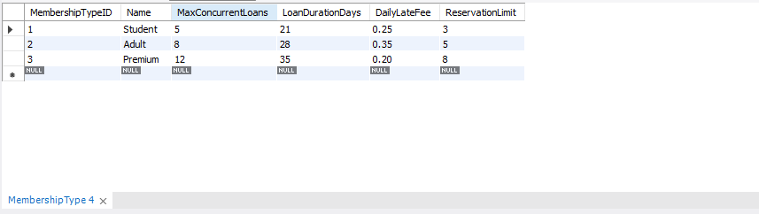
SELECT * FROM Client;
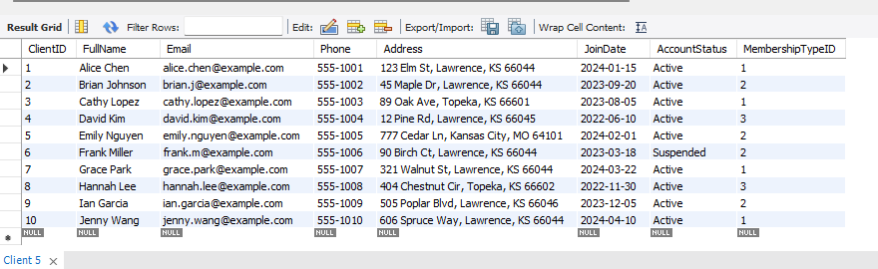
SELECT * FROM Item;
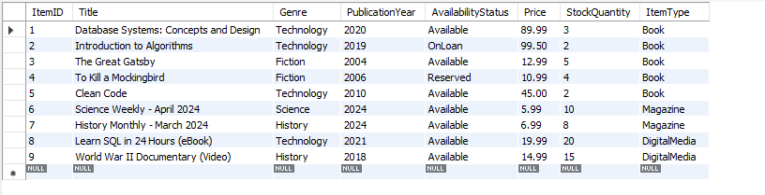
SELECT * FROM Book;
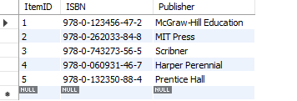
SELECT * FROM Magazine;
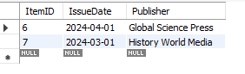
SELECT * FROM DigitalMedia;
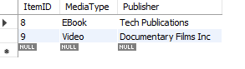
SELECT * FROM AuthorCreator;
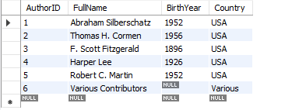

SELECT * FROM ItemAuthor;
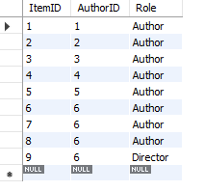
SELECT * FROM Loan;
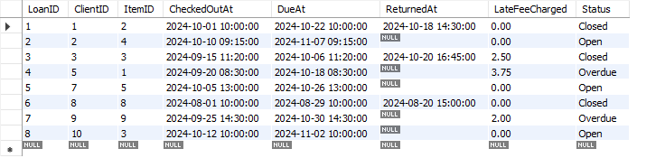
SELECT * FROM Reservation;
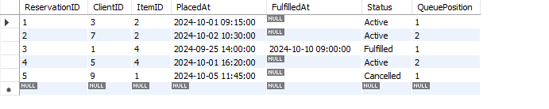
SELECT * FROM Payment;
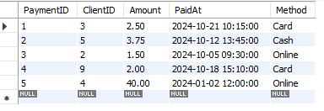
SELECT * FROM Notification;
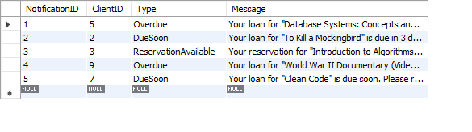

Functionality Testing
To meet the functionality testing requirements outlined in the project instructions, I created and executed a complete test_queries.sql file. These queries were designed based on the project requirements and verify that the database supports searching, borrowing, reservations, payments, and reporting features. All test queries executed successfully, confirming that the database is functioning correctly and satisfies the project specifications.

Fifth Project Meeting Notes
Date: November 12, 2025
Time: 8:00 PM – 9:00 PM
Location: Zoom Meeting

Objective: Allocate task for Part 5

Team Members Present: Jamie, K, Aidan, Maxwell

Task Completion Confirmation:
K Li: Completed all SQL scripts (create, populate, test), verified the physical database schema, and ensured the database is fully functional.
Aidan Lowry: Completed some of the tables and sketched out the introduction of the assignment.
Jamie King: Helped organize task distribution, assisted with part of part 2, reviewed work.
Maxwell Phachanla: Constructed the document, completed part of part 2, reviewed completed work, and uploaded the document to GitHub.

Brainstorming Session:
Team responsibilities:
Each member is responsible for one part of the Requirements Document.
Ensure drafts are uploaded to GitHub before the next meeting.
Review each other’s sections for consistency and clarity.
Tasks Allocated:
- [Aidan Lowry]: Task to make the tables and arrange the data.
- [Jamie King]: Responsible for task distribution, completion of part of the database code, and quality assurance.
- [K Li ]: Finalize SQL scripts and database-related sections for the project.
- [Maxwell Phachanla]: Responsible for layout of the document and part of part 2, as well as reviewing the document.

